Sri Lanka Institute of Information

Technology



Lab Submission

Lab No 04

**IT24103371**

**Fernando A.O.P.**

**Probability and Statistics | IT2120**

B.Sc. (Hons) in Information Technology

Exercise

1.





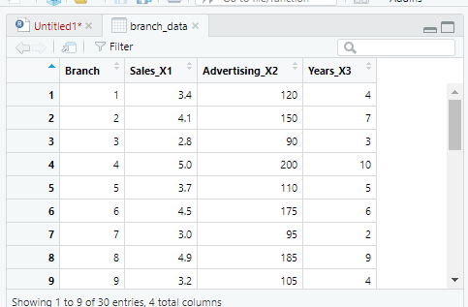

2.

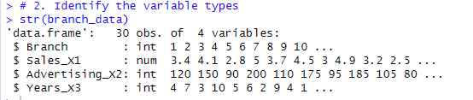

3.



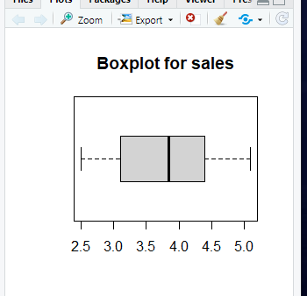

The black line is nearly in the middle of the box. Therefore, both sides of the box are the same length.

Interpretation: The sales distribution is balanced.

4.

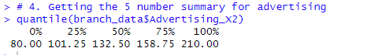



5.

